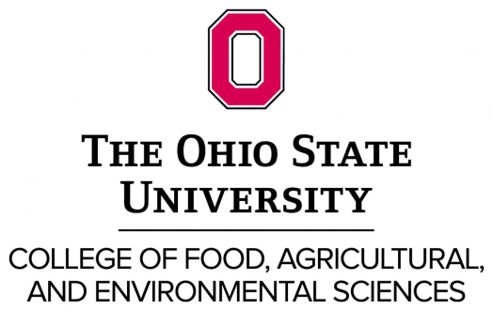

Food and Nutritional Metabolomics Computational Biology Faculty

The Ohio State University (OSU), College of Food, Agricultural and Environmental Sciences, College of Education and Human Ecology and the College of Medicine invite applicants for a tenure-track position at the rank of assistant, associate or full professor (9 month) in Food and Nutritional Metabolomics Computational Biology. This position is partially funded by Ohio State’s Discovery themes Initiative, a significant faculty hiring investment in key thematic areas in which the university can build on its culture of academic collaboration to make a global impact. This position will be housed in the Department of Food Science and Technology and may be joint with another department as appropriate.
Cross disciplinary training in biology and data sciences including machine learning, large data integration analysis and modeling is essential. Integration with other high-throughput disciplines and omics data is highly encouraged. Knowledge of targeted and untargeted metabolomics with a strong interest in developing and establishing an independent, collaborative program in food and nutrition related research is key. The successful candidate will interface with a collaborative group of researchers focused on: food and nutritional metabolic signatures, microbiome profiling, biomarker discovery, and biological pathway network mapping related to physiological processes and diet-related health and wellness outcomes.
Successful applicants will be expected to develop or maintain an externally funded research program in bioinformatics as related to foods and nutrition as well as contribute to the teaching (graduate and undergraduate) and service missions of the University.
The position contributes to a substantial investment (Discovery Themes) in key thematic areas in which the university will make a global impact. The Food and Nutritional Metabolomics Computational Biology position will connect with ongoing hires in data analytics (http://discovery.osu.edu/focus-areas/data-analytics/) currently being developed as part of the Discovery Themes. These new investments build upon existing strengths and a culture of academic collaboration to foster cross-disciplinary research to translate basic discoveries into applied outcomes. Partnerships with external stakeholders are encouraged and facilitated.
Preferred Qualifications: PhD in bioinformatics/computational biology, biochemistry, food science, engineering or other quantitative sciences, or related fields with experience and/or interest in food and nutritional metabolomics. Research productivity and evidence of, or potential for, an independently-funded research program should be demonstrated. Experience generating or analyzing metabolomic data and working in inter-disciplinary translational research teams, including those with industry stakeholders is desirable. Program experience, university teaching experience, experience in mentoring members of underrepresented groups is preferred. Applicants for appointment as Associate or Full Professor should have an existing extramurally funded research program.
To apply, please submit: cover letter, C.V., a statement of research plans, a statement of teaching philosophy, as well as a statement related to experience mentoring underrepresented groups, letters from four references, and transcripts. Send applications electronically to Yael Vodovotz, Search Chair, vodovotz.1@osu.edu, 2015 Fyffe Court, Parker Food Science Building, Columbus, OH 43210. Evaluation by search committee begins March 18, 2016, and continues until a suitable applicant is identified.
The Ohio State University is committed to establishing a culturally and intellectually diverse environment, and encouraging all members of our learning community to reach their full potential. We are responsive to dual-career families and strongly promote work-life balance to support our community members through a suite of institutionalized policies. We are an NSF Advance Institution and a member of the Ohio/Western Pennsylvania/West Virginia Higher Education Recruitment Consortium.
All qualified applicants will receive consideration for employment without regard to race, color, religion, sex, sexual orientation, gender identity, national origin, disability status, or protected veteran status.

