Data Analysis
- apLCMS (Yu 2009, Bioinformatics) with xMSanalyzer (Uppal 2013, BMC Bioinformatics): used for data extraction and quality evaluation
  - All batches are ran together as a whole with xMSanalyzer (include the cdf, profile, rawprof, etc). The R script will run through two multiple apLCMS parameter settings (3, 0.8) and (4, 0.5)
  - xMSanalzyer merges results from different parameter settings to enhance the quality of feature detection and filters poor quality features and samples based on coefficient of variation and Pearson correlation within technical replicates.
  - xMSanalyzer generates sample and quality reports. This information is included in the feature table worksheet
- Batch-effect evaluation and correction
  - Batch-effect evaluation is performed using PCA
  - Batch-effect correction is performed using ComBat (Johnson 2007, Biostatistics) implemented in the “sva” package in R Bioconductor
  - PCA plots are again generated to verify
- Annotation
  - xMSannotator

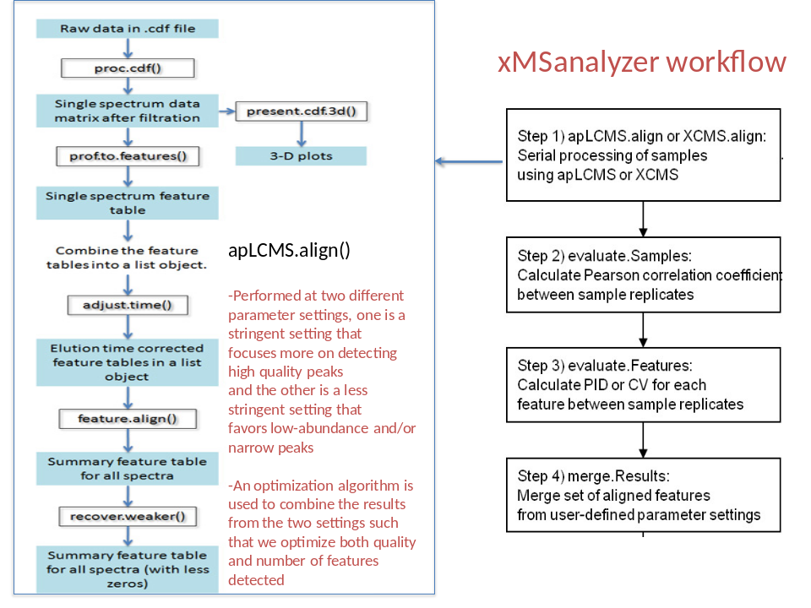
Figure 1. Data extraction: steps involved in apLCMS and xMSanalyzer
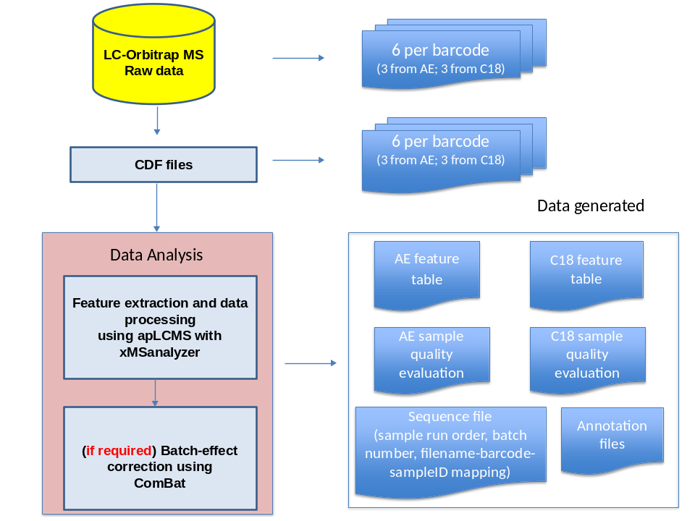
Figure 2. Overall data generation workflow

